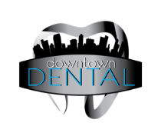

**Name: __________________________________________________ Date: ___________________________**

***Time______ Fear ________ Finances ________ are an obstacle (please check all that apply)***

**We can better recommend the most suitable preventive and corrective treatment for your individual needs, desires, and values if we understand what you want for yourself. In other words, we can’t represent your best interests if we don’t know what your best interests happen to be. Please help us personalize your care to meet your expectations by indicating your preferences or opinion below. Of the statements below separated by arrows, please circle the dotted line in the area that most represents YOU.**

I know a great deal about my dental condition

I like to be presented with fewer options

I tend to look at the details

I prefer long lasting solutions that may cost more

I prefer to talk in technical terms

My insurance largely determines the extent of my care

I prefer to wait until I must act

I rely more on self-maintenance

**🡨--------------------🡪**

**🡨--------------------🡪**

**🡨--------------------🡪**

**🡨--------------------🡪**

**🡨--------------------🡪**

**🡨--------------------🡪**

**🡨--------------------🡪**

**🡨--------------------🡪**

I know very little about my dental condition

I like to be presented with more options

I tend to look at the big picture

I prefer more temporary solutions at a lower cost

I prefer to talk in non-technical terms

I largely determine the extent of my care

I prefer a preventive approach

I rely more on professional maintenance